A Project on

## Tutorial and Exam Portal



Created By:

Ganesh Shid

Hemant Jadhav

**ACKNOWLEDGEMENT**

* I would like to pay my praise and humblest thanks to God, the most merciful and beneficiate of me, who bestowed me with the ability to complete this project.
* I heartily wish to take this opportunity to express my gratitude to my teachers and friends for how they have helped me a lot in completing my project.
* I am very grateful to my lecturer,**“** **Prof. Meghali Bramankar** ” for his explanations and constant guidance throughout the project.
* I would also like to give thanks to our **H.O.D. Yadav mam** for her valuable support, help and guidance whenever needed.
* I am very grateful to my lab instructor whose suggestions helped me a lot while project work in progress and I am also grateful to the non-teaching staff for helping me in laboratory in various ways.
* I would like to extend my gratitude to those friends whose knowledge and time had been given to help me in different ways.

**Index**

|  |  |  |  |
| --- | --- | --- | --- |
| Sr. No |  | Particulars | Page No. |
|  |  |  |  |
| 1 |  | Abstract |  |
| 2 |  | Introduction |  |
|  | 2.1 | Existing System |  |
|  | 2.2 | Proposed System |  |
|  | 2.3 | Scope |  |
|  |  |  |  |
| 3 |  | Feasibility Study |  |
| 4 |  | Requirement Specification |  |
|  | 4.1 | Hardware Configuration |  |
|  | 4.2 | Software Requirement |  |
| 5 |  | System Design |  |
|  | 5.1 | Collaboration Diagram |  |
|  | 5.2 | Deployment Diagram |  |
|  | 5.3 | Component Diagram |  |
|  | 5.4 | State Chart Diagram(Admin) |  |
|  | 5.5 | State Chart Diagram(User) |  |
|  | 5.6 | Use Case Diagram |  |
|  | 5.7 | Output Diagram |  |
| 6 |  | Reports Testing |  |
| 7 |  | Conclusion |  |
| 8 |  | Reference |  |

**Abstract**

As we see over this year there are so many people who want their own business, there are many applications for online Tutorial and exam portal and so on. The purpose of this project is to provide services for students for tutorial. It’s objective is to save the Students time and so they can do there studies without moving from one place. We have created this application so that students learn from tutorial. Also in this we provide services like online tutorial and exam portal. It is easy to manipulate and access that is, it is in simple language that is understandable for the Student and also efficient to use.

Online tutorial and exam portal is being launched because a need for a destination that beneficial for both institues and students with this site, institutes can register and use. Students can give exam and view their results.

In this it also shows the information and description of the tutorial and see all the details. Also provides various searching content categories like languages , types, Questions. Also it is efficient because it provide output.

**Keywords**:-Online Tutorial, Online Exam portal.

**Introduction**

**Introduction:-**

In today’s time there are so many people who want to start their own business , there are many applications for online Tutorial and exam portal and so on. The purpose of this project is to provide services for students for tutorial. It’s objective is to save the Students time and so they can do there studies without moving from one place. We have created this application so that students learn from tutorial. Also in this we provide services like online tutorial and exam portal. It is easy to manipulate and access that is, it is in simple language that is understandable for the Student and also efficient to use. In this it also shows the information and description of the tutorial and see all the details. Also provides various searching content categories like languages , types, Questions. Also it is efficient because it provide output.

## *Existing System*

## The existing reference application are basesd on the static document concept. And commonly these type pf application are

## Available on online . ie, Online type . The content of the apllications is depends on the admisnistrator, so thus make a problem that the pupation’s are not made directlty by user.

## There is also another problem behind that online concept that the personal information such like tutorial name , details

## Its available on the existing system.

System

The existing reference application are based on the static document concept.

And commonly these type of application are available on online.ie, online type.

The content of the application is depend on the administrator, so thus make a

problem that the pupation’s are not made directly by user.

There is also another problem behind that online concept that the personal

information such like text book name, details its documents are available on the

existing system. This application can overcome this problem by using system

database

System

The existing reference application are based on the static document concept.

And commonly these type of application are available on online.ie, online type.

The content of the application is depend on the administrator, so thus make a

problem that the pupation’s are not made directly by user.

There is also another problem behind that online concept that the personal

information such like text book name, details its documents are available on the

existing system. This application can overcome this problem by using system

database

System

The existing reference application are based on the static document concept.

And commonly these type of application are available on online.ie, online type.

The content of the application is depend on the administrator, so thus make a

problem that the pupation’s are not made directly by user.

There is also another problem behind that online concept that the personal

information such like text book name, details its documents are available on the

existing system. This application can overcome this problem by using system

database

System

The existing reference application are based on the static document concept.

And commonly these type of application are available on online.ie, online type.

The content of the application is depend on the administrator, so thus make a

problem that the pupation’s are not made directly by user.

There is also another problem behind that online concept that the personal

information such like text book name, details its documents are available on the

existing system. This application can overcome this problem by using system

database

System

The existing reference application are based on the static document concept.

And commonly these type of application are available on online.ie, online type.

The content of the application is depend on the administrator, so thus make a

problem that the pupation’s are not made directly by user.

There is also another problem behind that online concept that the personal

information such like text book name, details its documents are available on the

existing system. This application can overcome this problem by using system

datab

.

The existing reference application are based on the static document concept.

And commonly these type of application are available on online.ie, online type.

The content of the application is depend on the administrator, so thus make a

problem that the pupation’s are not made directly by user.

There is also another problem behind that online concept that the personal

information such like text book name, details its documents are available on the

existing system. This application can overcome this problem by using system

databas

## *Proposed System*

Now USER can overcome these problem by using system database and customize as per user requirement. The objective of this applications is to

allow every user to edit and find out the details. It’ll also facility store new

user. And is can retrive within few seconds. Overall, it’ll make an easier way to access all documents and details by using the USER application.

The administrator privilege is used to update the users profile.

Thus overcome all the drawback pf the existing system.

**Requirement Specification**

**Hardware Requirement:**

**Client-Side:**

|  |  |
| --- | --- |
| **RAM** | 8 GB |
| **Hard disk** | 1 TB |
| **Processor** | 7 GHz |

**Server-side:**

|  |  |
| --- | --- |
| **RAM** | **1 GB** |
| **Hard disk** | **20 GB** |
| **Processor** | **2.0 GHz** |

**Software Requirement:**

**Client Side:**

|  |  |
| --- | --- |
| **Web Browser** | Google Chrome or any compatible browser |
| **Operating System** | Windows or any equivalent OS |

**HTML:-**

HTML (Hypertext Markup Language) was developed to address the need to easily display content via a web-browser.

It is a 'markup language (unlike a typical programming language), in that its commands (tags) are designed to assist in the formatting and layout of textual data. It by definition is a 'static' language, in that the content displayed using the standard HTML language will always look the same it will not change over time or by who accessed it.

Due to this major limiting factor of the language in this modern world of dynamic. data-driven websites, a variety of extensions to HTML and related programming languages have been developed JavaScript, Microsoft's ASP (Active Server Pages), Java Applets and Applications, PHP, others...

**MySQL:-**

MySQL pronounced either "My S-Q-L" or "My Sequel, is an open-source relational database management system. It is based on the structure query language (SQL), which is used for adding, removing, and modifying information in the database Standard SQL commands, such as ADD, DROP, INSERT, and UPDATE can be used with MySQL.

MySQL can be used for a variety of applications but is most commonly found on Web servers. A website that uses MySQL may include Web pages that access information from a database. These pages are often referred to as 'dynamic," meaning the content of each page is generated from a database as the page loads. Websites that use dynamic web pages are often referred to as database-driven websites.

Many database-driven websites that use MySQL also use a Web scripting language like PHP to access information from the database. MySQL. commands can be incorporated into the PHP code, allowing part or all of a Web page to be generated from database information. Because both MySQL and PHP are both open source (meaning they are free to download and use), the PHP/MySQL combination has become a popular choice for database-driven websites.

**CSS:-**

Cascading Style Sheets (CSS) is a style sheet language used for describing the look and formatting of a document written in a markup language. While most often used to change the style of web pages and user interfaces written in HTML and XHTML, the language can be applied to any kind of XML document, including plain XML, SVG, and XUL They can be used to define text styles, table sizes, and other aspects of Web pages that previously could only be defined in a page's HTML. While CSS is great for creating text styles, it is helpful for formatting other aspects of Web page layout as well. For example, CSS can be used to define the cell padding of table cells, the style, thickness, and colour of a table's border, and the padding around images or other objects CSS gives Web developers more exact control over how Web pages will look than HTML does. This is why most Web pages today incorporate cascading style sheets.

**JAVASCRIPT:-**

**JavaScript** (**JS**) is a lightweight, interpreted, or just in time compiled programming language with first-class function. While it is most well-known as the scripting language for the Web many non-brows environments also use it, such as node.js, and Apache CouchDB. JavaScript is a prototype-based, multi-paradigm, single-threaded, dynamic language, supporting object-oriented, imperative, and declarative (e.g. functional programming) styles. Read more about JavaScript.

This section is dedicated to the JavaScript language itself, and not the parts that are specific to Web pages or other host environments. For information about API specifics to Web pages, please see Web APIs and DOM.

The standards for JavaScript are the ECMAScript Language Specification  (ECMA-262) and the ECMAScript internationalization API specification   (ECMA-402). The JavaScript documentation throughout MDN is based on the latest draft versions of ECMA-262 and ECMA-402. And in cases where some proposals for new ECMAScript Features have already been implemented in browsers, documentation, and examples in MDN articles may use some of those new features.

Do not confuse JavaScript with the Java programming language. Both "Java" and "JavaScript" are trademarks or registered trademarks of Oracle in the U.S. and other countries. However, the two programming languages have very different syntax, semantics, and use.

**Python :**

Python is used for server-side web development, software development, mathematics, and system scripting, and is popular for Rapid Application Development and as a scripting or glue language to tie existing components because of its high-level, built-in data structures, dynamic typing, and dynamic binding. Program maintenance costs are reduced with Python due to the easily learned syntax and emphasis on readability. Additionally, Python's support of modules and packages facilitates modular programs and reuse of code. Python is an open source community language, so numerous independent programmers are continually building libraries and functionality for it.

**React.Js:**

ReactJS is JavaScript library used for building reusable UI components. According to React official documentation, following is the definition −

React is a library for building composable user interfaces. It encourages the creation of reusable UI components, which present data that changes over time. Lots of people use React as the V in MVC. React abstracts away the DOM from you, offering a simpler programming model and better performance. React can also render on the server using Node, and it can power native apps using React Native. React implements one-way reactive data flow, which reduces the boilerplate and is easier to reason about than traditional data binding.

Feasibility Study



##### **Feasibility Study**

Depending on the results of the initial investigation the survey is now expanded to a more detailed feasibility study. “FEASIBILITY STUDY ” is a test of system proposal according to its workability, impact of the organization, ability to meet needs and effective use of the resources.

Questions:

1. What are the user’s demonstrable needs and how does a candidate system meet them?
2. What resources are available for given candidate system?
3. What are the likely impacts of the candidate system on the organization? 4.Whether it is worth to solve the problem?

During feasibility analysis for this project, following primary areas of interest are to be considered. Investigation and generating ideas about a new system does this. Steps in feasibility analysis Eight steps involved pg. 12 in the feasibility analysis are: Form a project team and appoint a project leader.

Enumerate potential proposed system. Define and identify characteristics of proposed system. Determine and evaluate performance and cost effective of each proposed system.

* + Economical Feasibility
  + Technical Feasibility
  + Behavioural Feasibility

**Economical Feasibility**



Justification is generally the “Bottom Line” consideration for most systems. Economic justification includes a broad range of concerns that includes cost benefit analysis. In this we weight the cost and the benefits associated with the candidate system and if it suits the basic purpose of the organization i.e., profit making, the project is making to the analysis and design phase. The financial and the economic questions during the preliminary investigation are verified to estimate the following:

The cost of hardware and software for the class of application being considered.

The benefits in the form of reduced cost.

The proposed system will give the minute information, as a result the performance is improved which in turn may be expected to provide increase profits.

**Technical Feasibility**



A study of resource availability that may affect the ability to achieve an acceptable system. This evaluation determines whether the technology needed for the proposed system is available or not.

Can the work for the project be done with current equipment existing software technology & available personal?

Can the system be upgraded if developed?

If new technology is needed then what can be developed?

This is concerned with specifying equipment and software that will successfully satisfy the user requirement.

**Behavioural Feasibility**



Time evaluation is the most important consideration in the development of project. The time schedule required for the developed of this project is very important since more development time effect machine time, cost and cause delay in the development of other systems. A reliable ecommerce platform for farmers can be developed in the considerable amount of time.

Design

**USECASE DIAGRAMS**

Use case diagrams model behaviour within a system and helps the developers understand of what the user require. The stick man represents what’s called an Use case diagram can be useful for getting an overall view of the system and clarifying who can do and more importantly what they can’t do.

Use case diagram consists of use cases and actors and shows the interaction between the use case and actors.

* The purpose is to show the interactions between the use case and actor.
* To represent the system requirements from user’s perspective.
* An actor could be the end-user of the system or an external system.

**USECASE DIAGRAM:** A Use case is a description of set of sequence of actions. Graphically it is rendered as an ellipse with solid line including only its name. Use case diagram is a behavioural diagram that shows a set of use cases and actors and their relationship. It is an association between the use cases and actors. An actor represents a real-world object. Primary Actor – Sender, Secondary Actor Receiver.

Login

Create Account

Add Student

Add Video Tutorial

Add Tutorial

Add Exam Question

Add Topic

**User**

**Admin**

Text Tutorial

Video Tutorial

f

Get Exam

Code Editor

Result

**Use Case Diagram**

**Design Introduction:**

Design is the first step in the development phase for any techniques and principles for the purpose of defining a device , a process or system in sufficient detail to permit its physical realization.

Once the software requirements have been analysed and specified the software design involves three technical activities - design, coding, implementation and testing that are required to build and verify the software.

The design activities are of main importance in this phase, because in this activity, decisions ultimately affecting the success of the software implementation and its ease of maintenance are made. Design is the only way to accurately translate the customer’s requirements into finished software or a system.

**Deployment Diagram**

Monitor

Processor

Printer

Keyboard

**Component Diagram**

Login

Tutorial Section

Database

Exam Portal and Tutorial

Exam Section

Result

Logout

**State Chart Diagram(For Admin)**

Create Account

Login

Verify Not –verify Check Password,

Username

Successful Login

Update Details

Add details

Add a Student Exam, Tutorial, video Tutorial

**AAa**

if

Delete Tutorial ,Video

Logout

**State Chart Diagram(For User)**

Registration

Login

verify non-verify check Password,

Successful Login

UserName

Check Tutorial Section, Exam

Update Details

Login

**Collaboration Diagram**

Admin

Webframe Work

User

Student tutorial ,Student exam, video tutorial, text tutorial

**Output ScreenShots**

**Admin Login**

Login:-

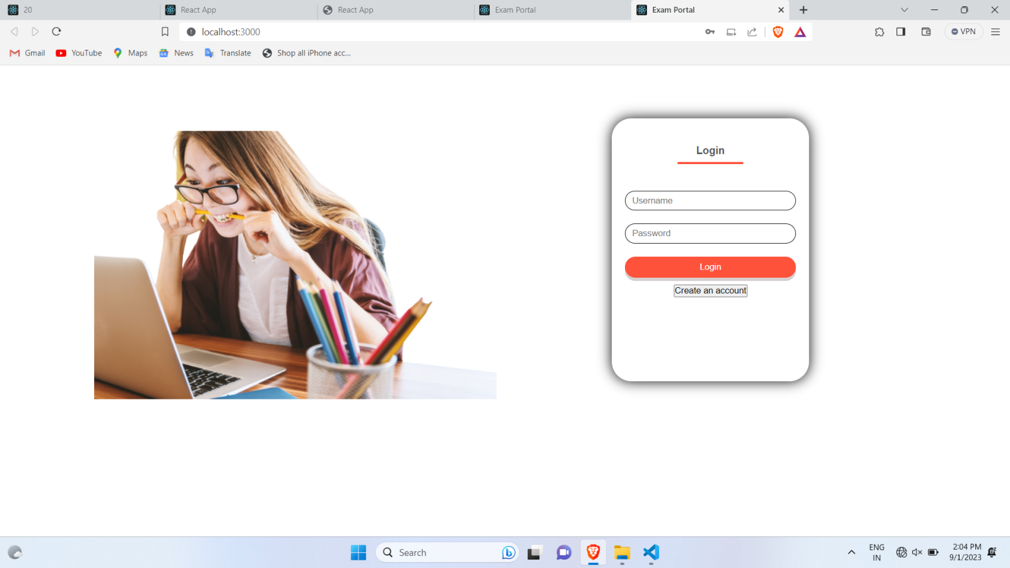

Login Successful:-

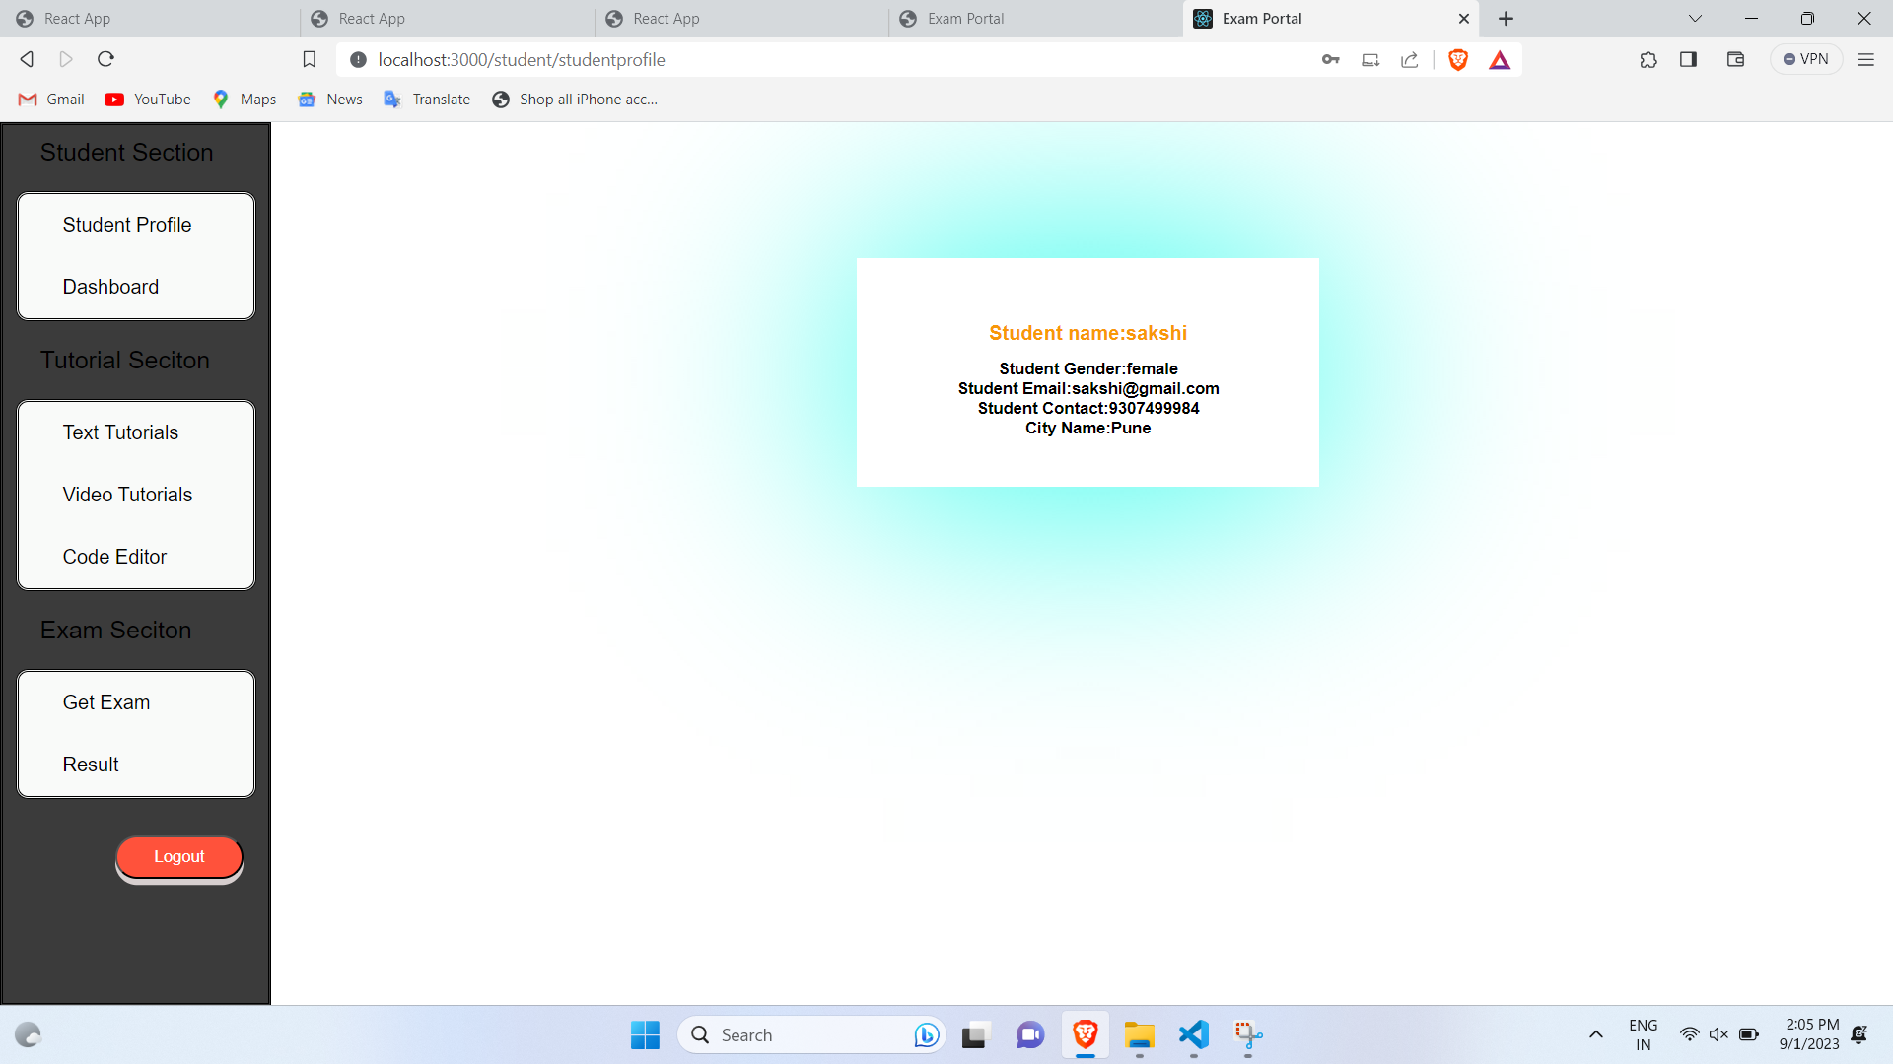

Add Students Details:-

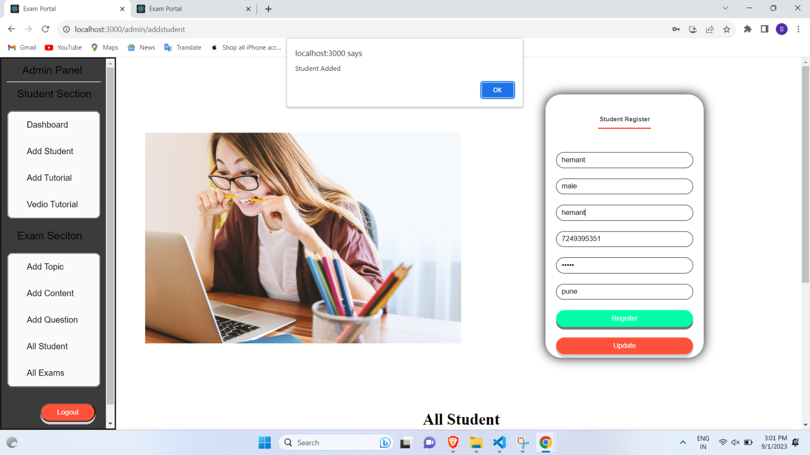

Add Tutorial Section:-

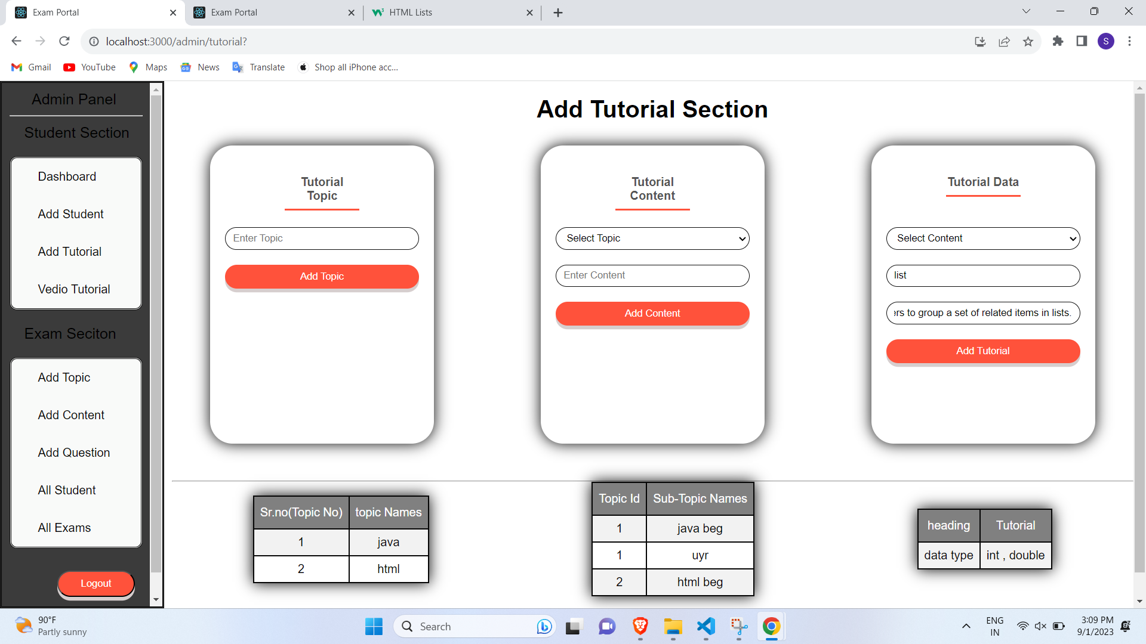

Add a Exam Question

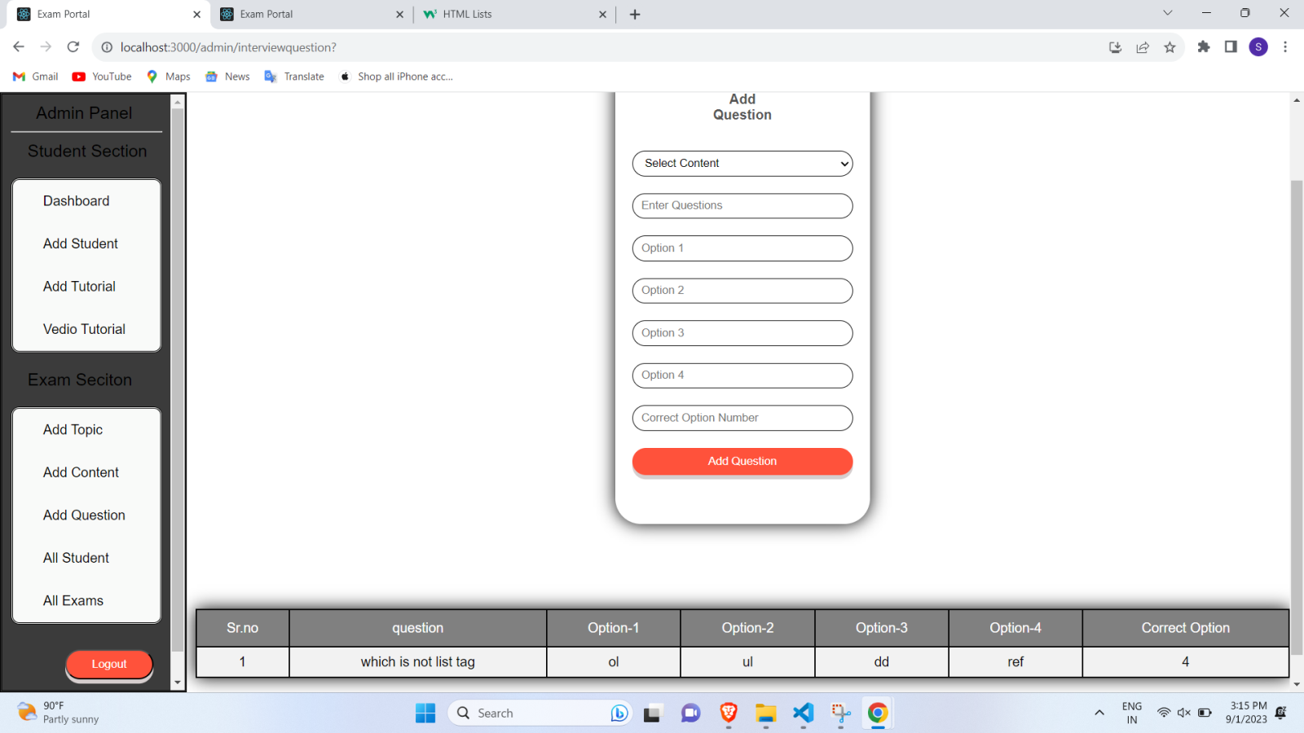**User Login**

Students Login information:-

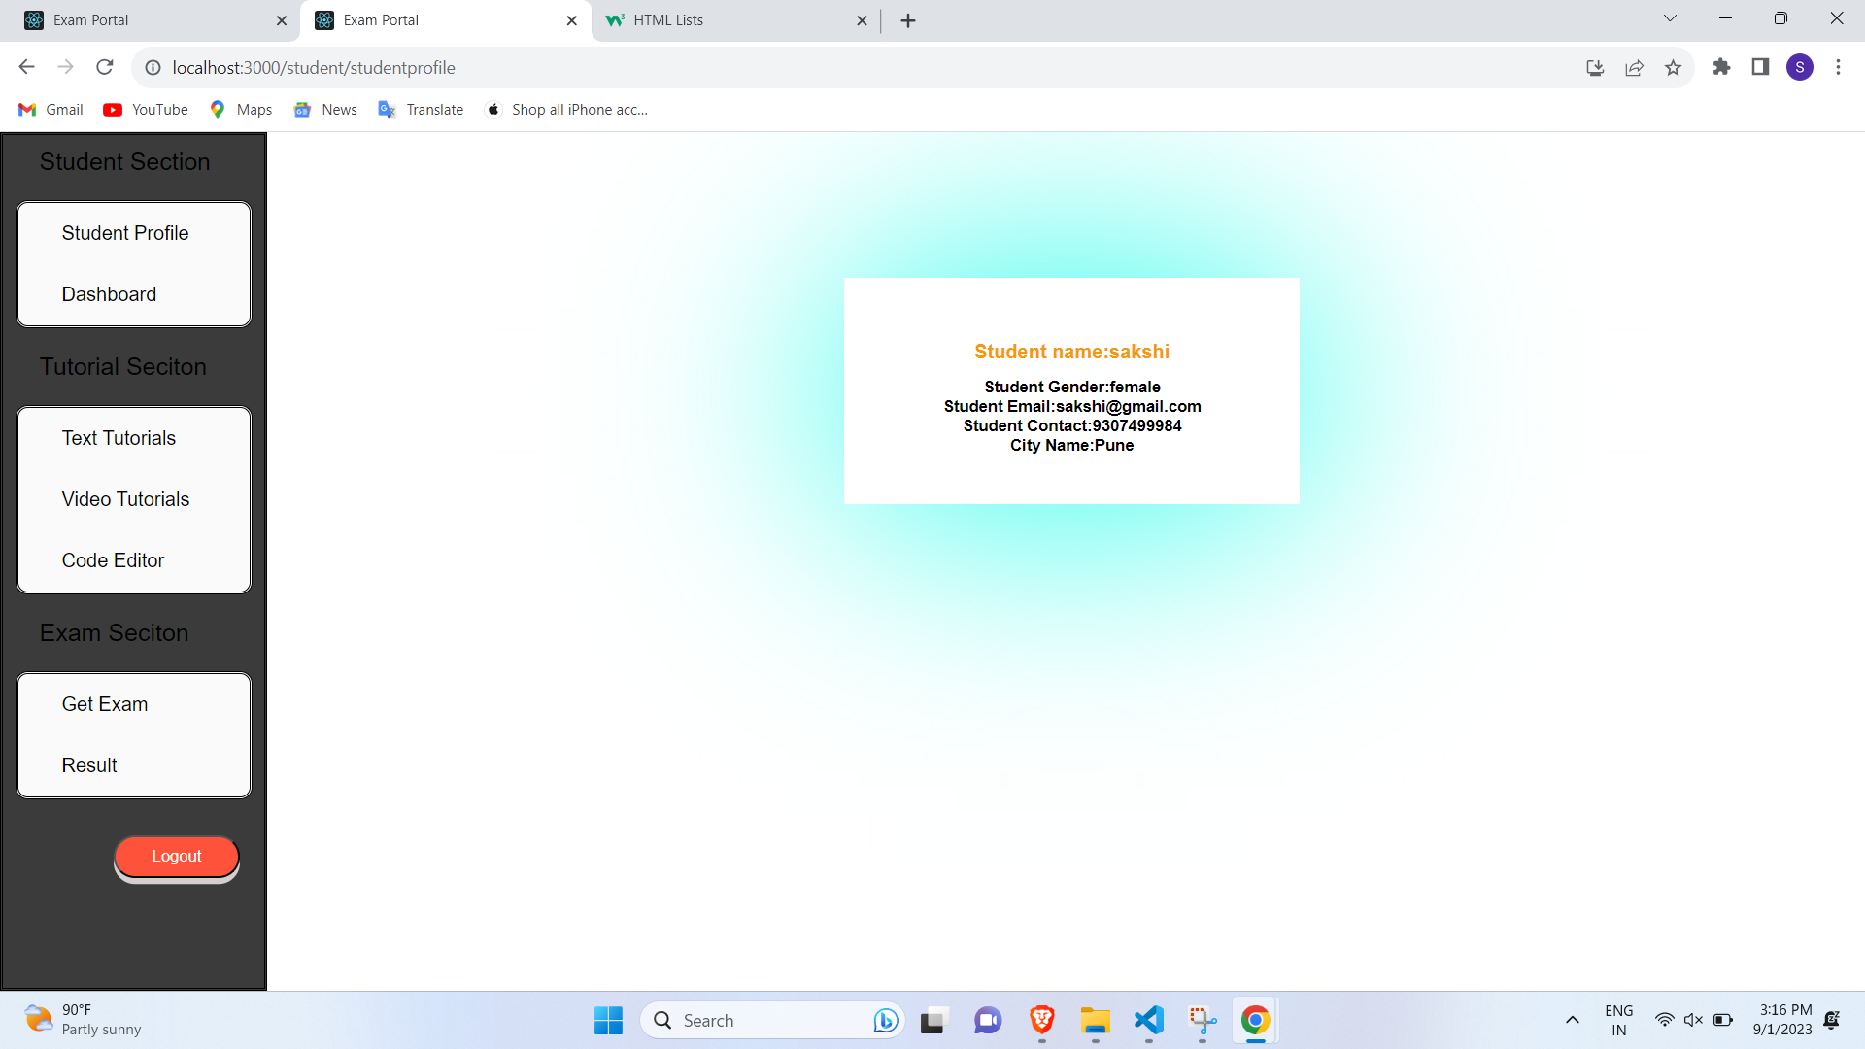

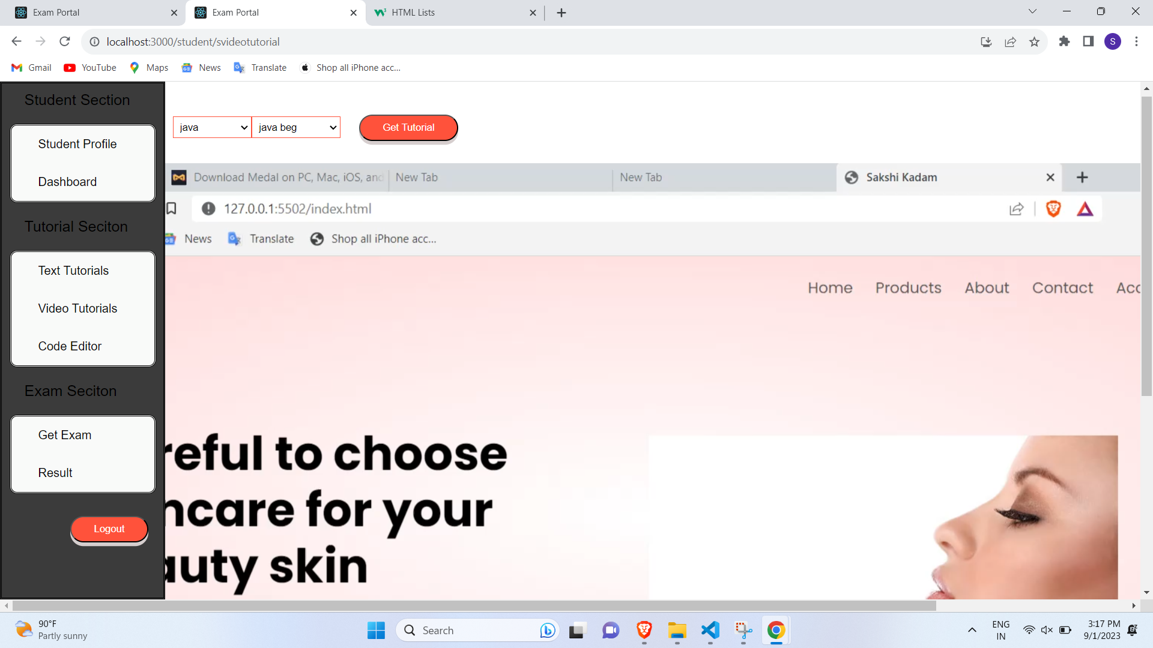

Video Tutorial:-

Exam test:-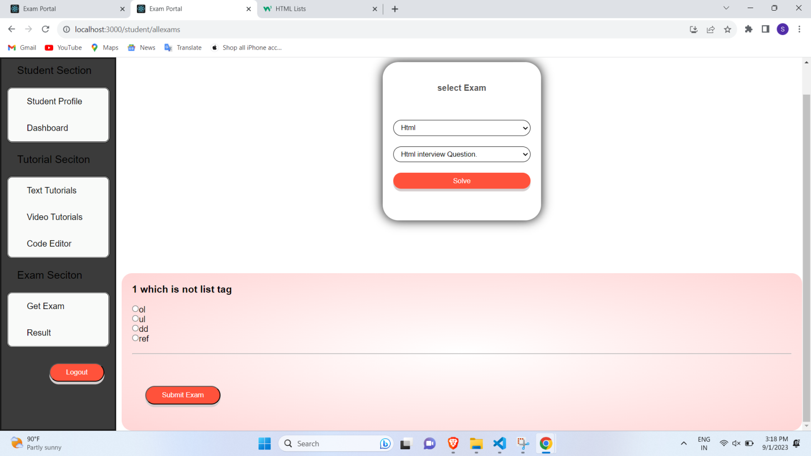

Tutorial :- 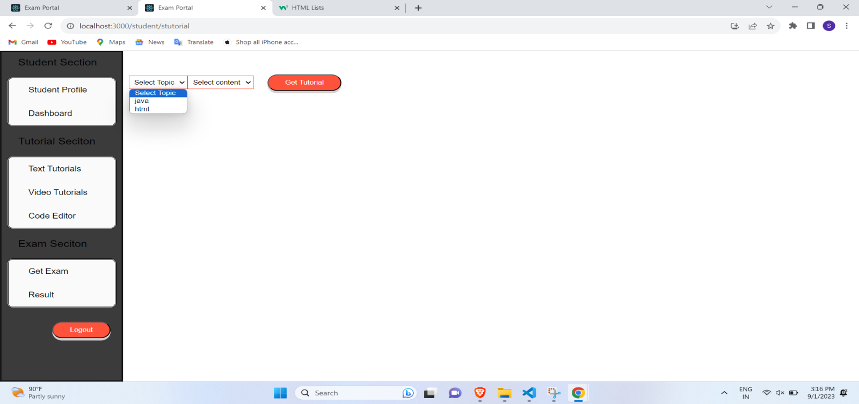Exam Result:-

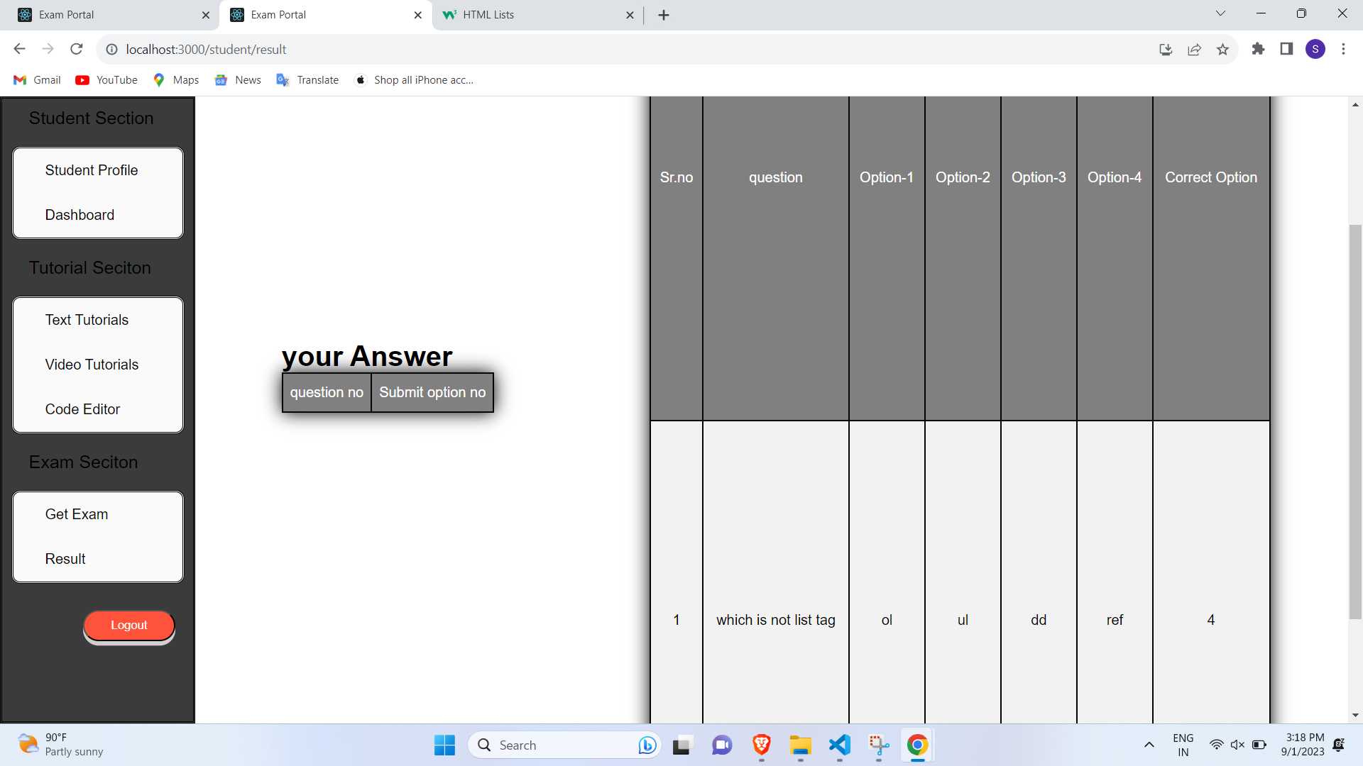

**User Login**

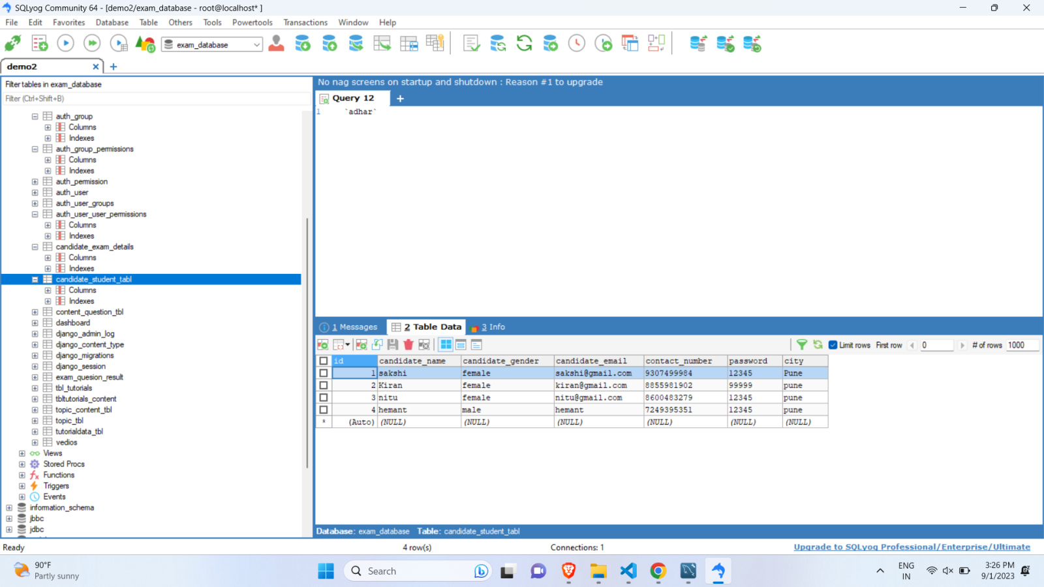

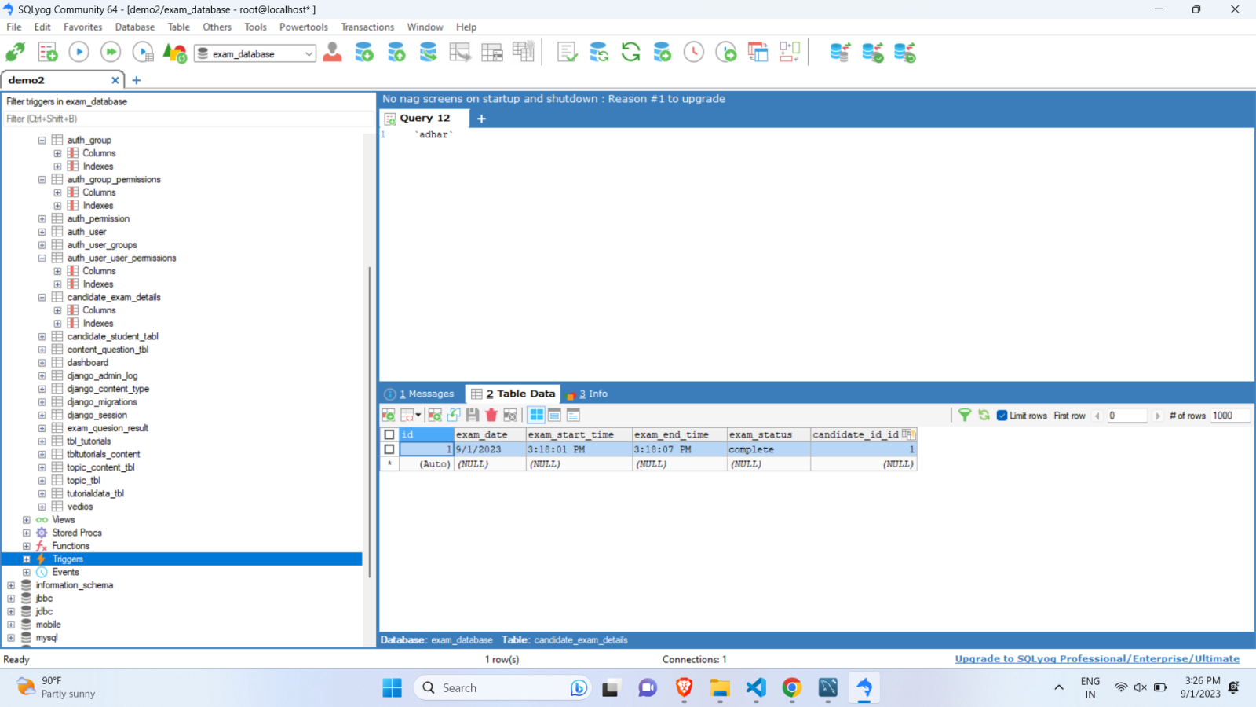

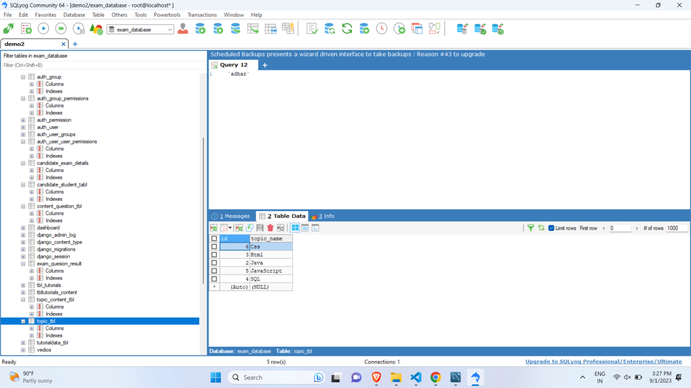

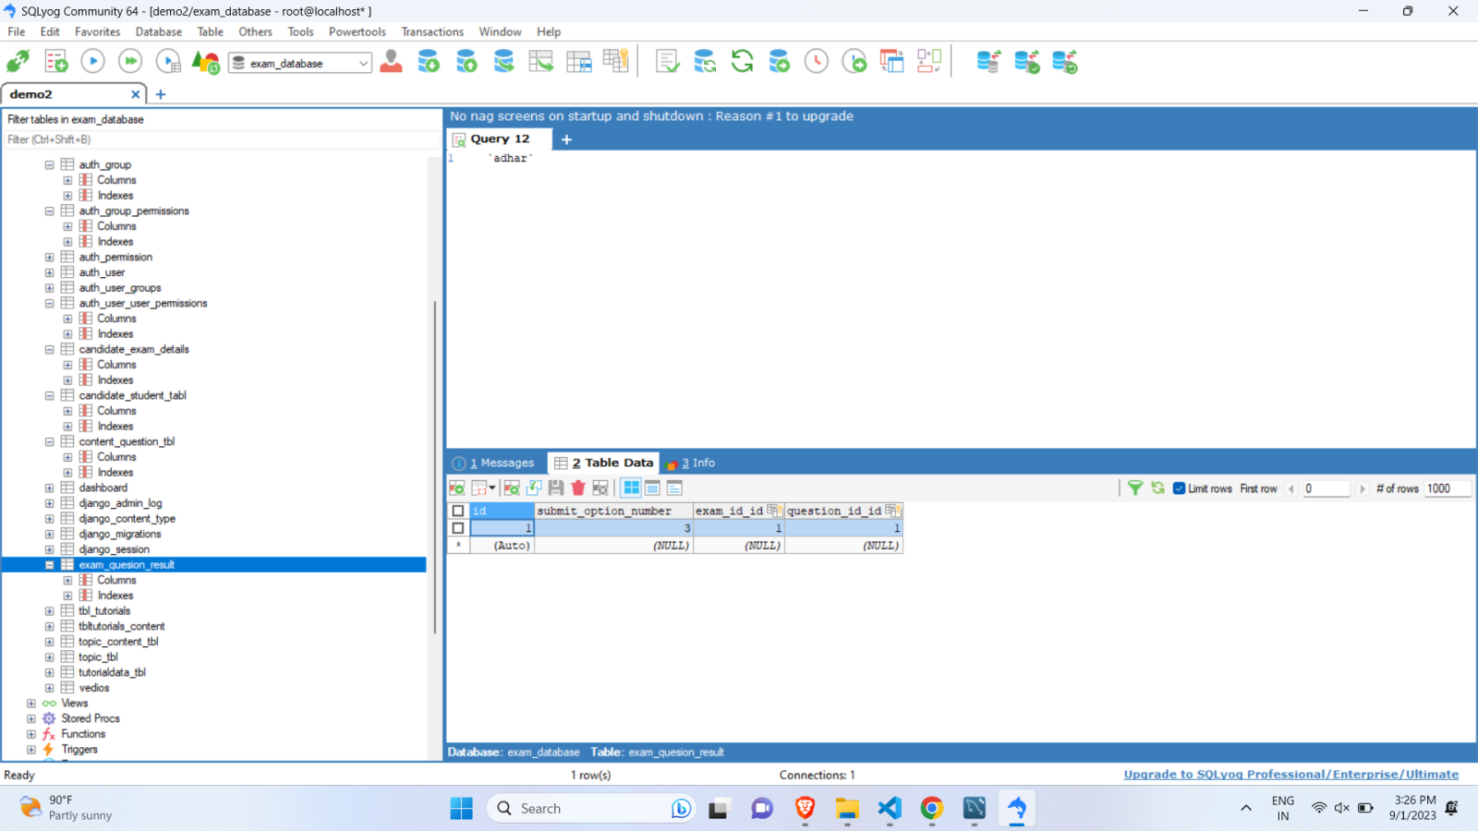

**REPORTS TESTING**

**Testing**

**Software testing** is the process of testing software in a controlled manner to ensure that it behaves the way it is expected to behave. Software testing is, thus a critical element of software quality assurance. Testing requires that the developer discards preconceived notices of the correctness of the software just developed and overcome the conflict of interest that occurs when errors are revealed.

**Black Box Testing** Testing without knowledge of the internal workings of the item being tested. Tests are usually functional.

**Functional Testing** Validating an application or Web site conforms to its specifications and correctly performs all its required functions. This entails a series of tests that perform a feature-by-feature validation of behaviour, using a wide range of normal and erroneous input data. This can involve testing the product's user interface, APIs, database management, security, installation, networking, etc. testing can be performed on an automated or manual basis using black box or white box methodologies.

**White Box Testing** Testing is based on an analysis of the internal workings and structure of a piece of software. Includes techniques such as Branch Testing and Path Testing Also known as Structural Testing and Glass Box Testing

**CONCLUSION**

Our analysis showed that online Tutorial and exam portal is useful for both Admin & User. Also, this system can be reliable, secure & fast online Tutorial and Exam Portal.

* Online Tutorial is very useful to students.
* Exam can be taken at any time.
* Faster results calculation.
* Reduced cost.

***References***

**For HTML , CSS , JAVASCRIPT**

* https://www.w3schools.com/
* <http://www.wikipedia.com>
* https://www.tutorialspoint.com/reactjs/reactjs_overview.htm

**For MySQL**

* <https://www.mysql.com/>
* [http://www.mysqltutorial.org](http://www.mysqltutorial.org/)
* http://www.mysqlworkbench8.0CE.com

Thank You

Ganesh Shid

Hemant Jadhav